Objective: Modify E-bikes project to Car Dealers website.

In this exercise, you will make UI modifications to the E-bikes project to convert it to car dealer’s application. The existing images and logos in the E-bikes project are replaced with car images and logos and also the data-model, UI and data is modified according to Car data. The project is modified locally and then pushed/pulled to/from the scratch org.

Step 1.1: Create a new scratch org

Step 1.1.1: Open ebikes project in your Visual Studio Code.

Step 1.1.2: Authenticate your hub org and provide it with an alias (myhuborg in the command below) in the terminal:

sfdxforce:auth:web:login -d -a myhuborg

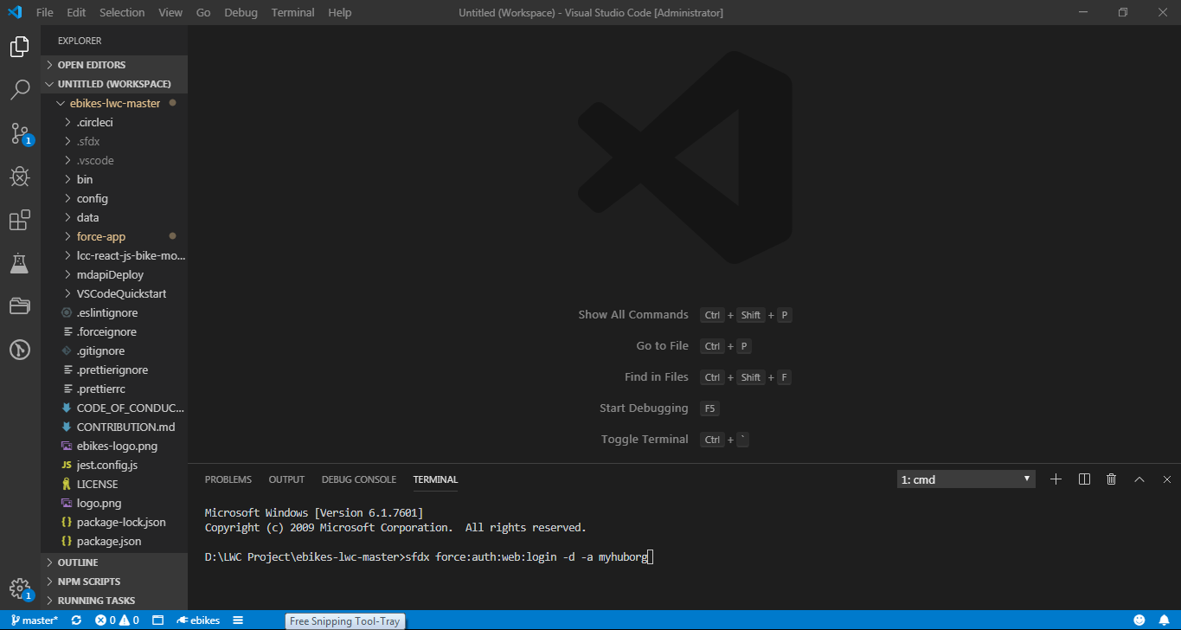

Step 1.1.3: Login to your org and authorize

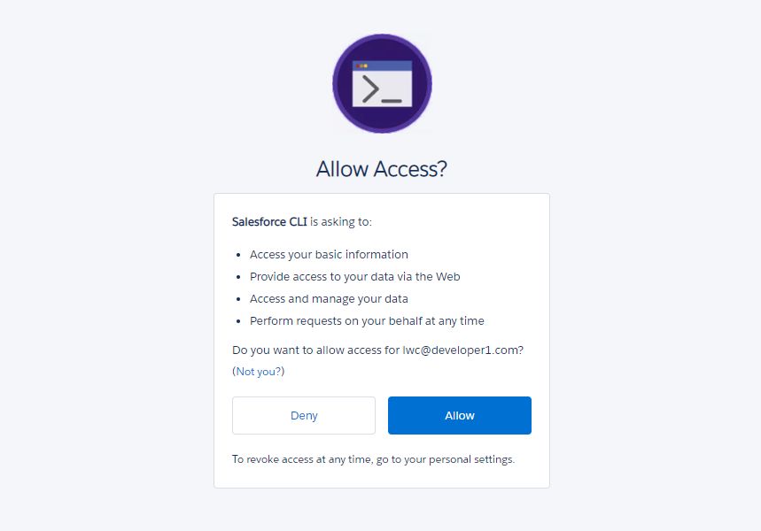

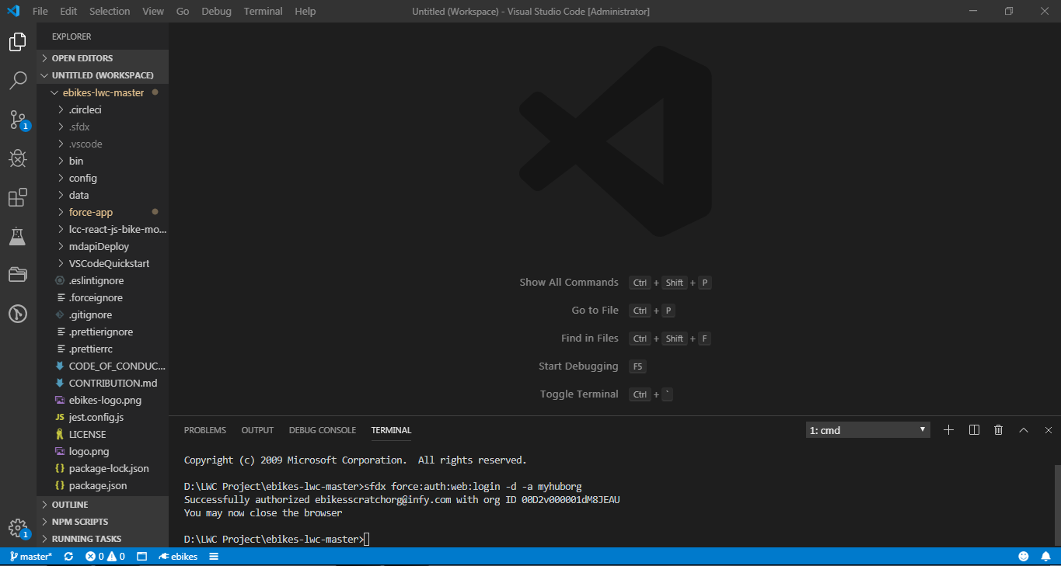

Step 1.1.3: Create a scratch org and provide it with an alias (ebikes in the command below):

sfdxforce:org:create -s -f config/project-scratch-def.json -a ebikes

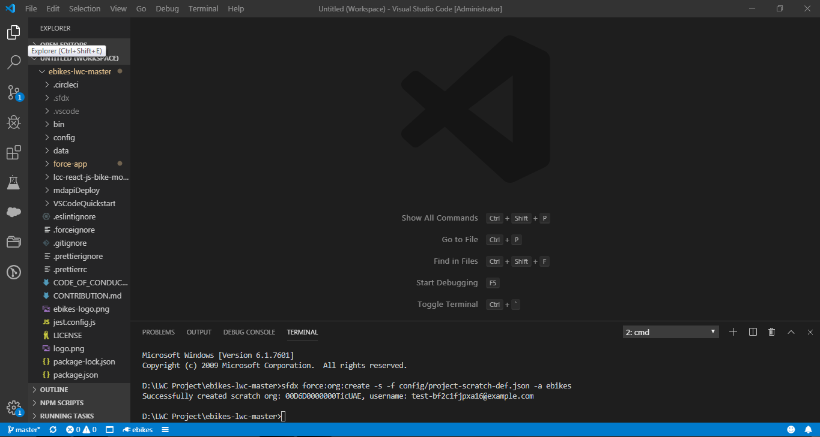

Step 1.2: Assign Permissions, Change the data model.

Step 1.2.1: Push the app to your scratch org:

Sfdx force:source:push

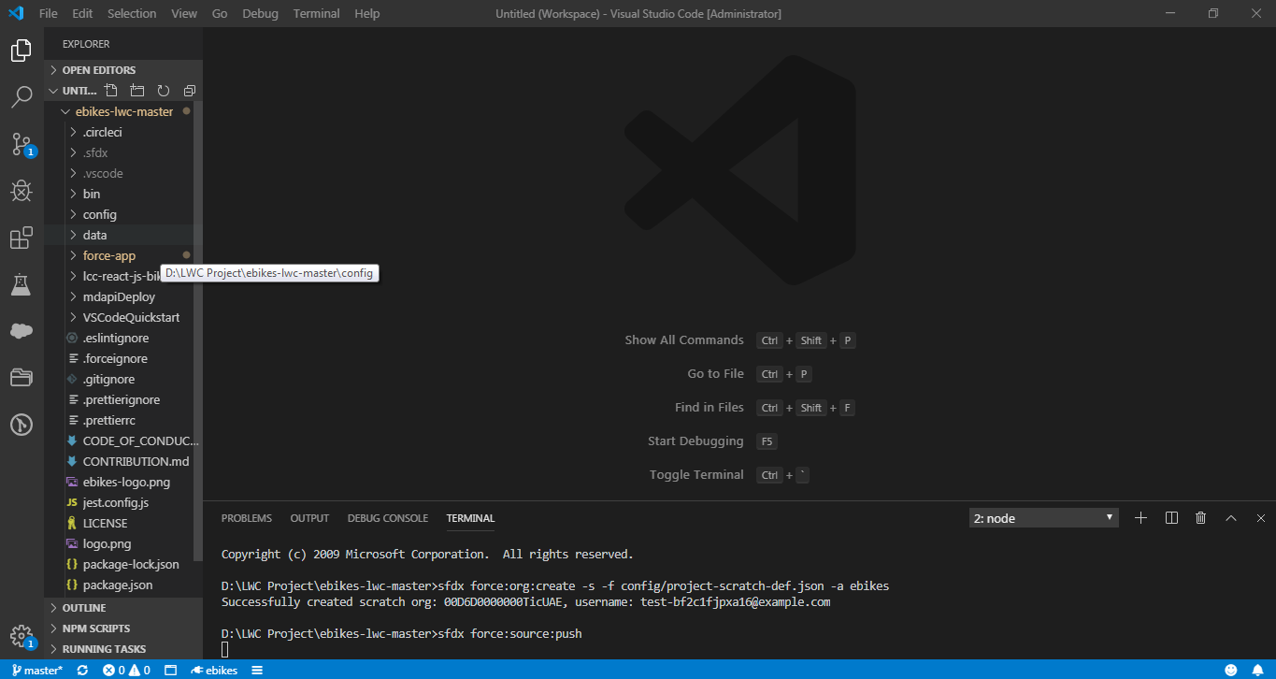

Step 1.2.2: Assign the ebikes permission set to the default user:

Sfdx force:user:permset:assign -n ebikes

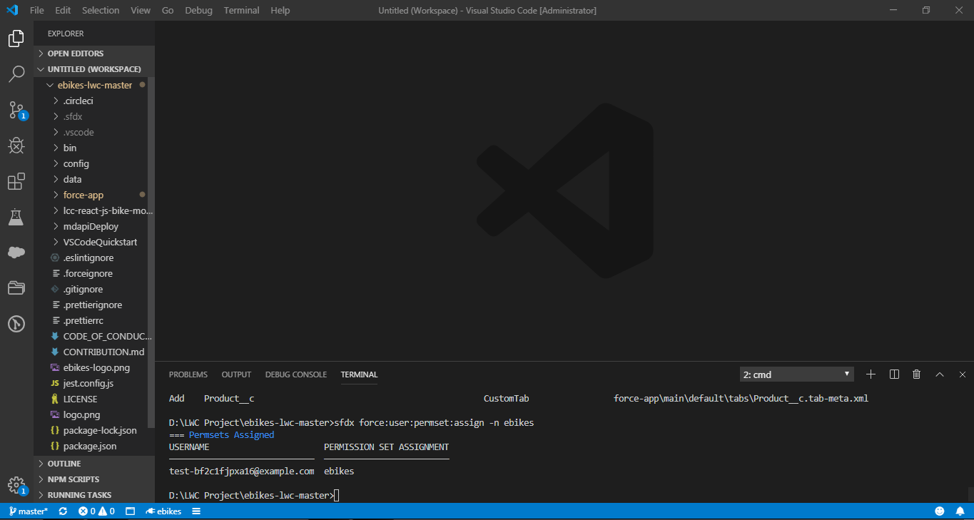

Step 1.2.3: Load Sample Data

sfdx force:data:tree:import –plan ./data/sample-data-plan.json

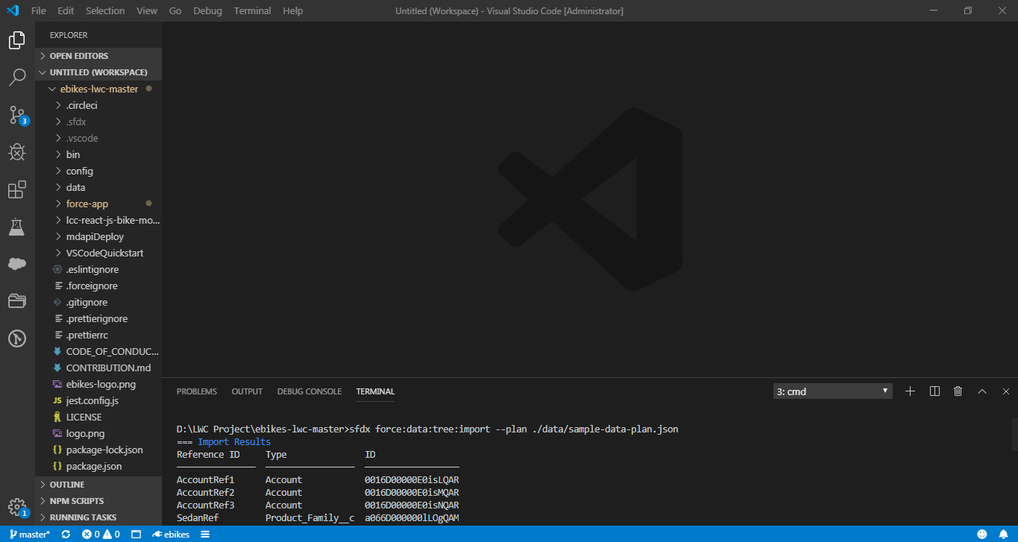

1.2.4. Open scratch org and explore Ebikes app

sfdxforce:org:open

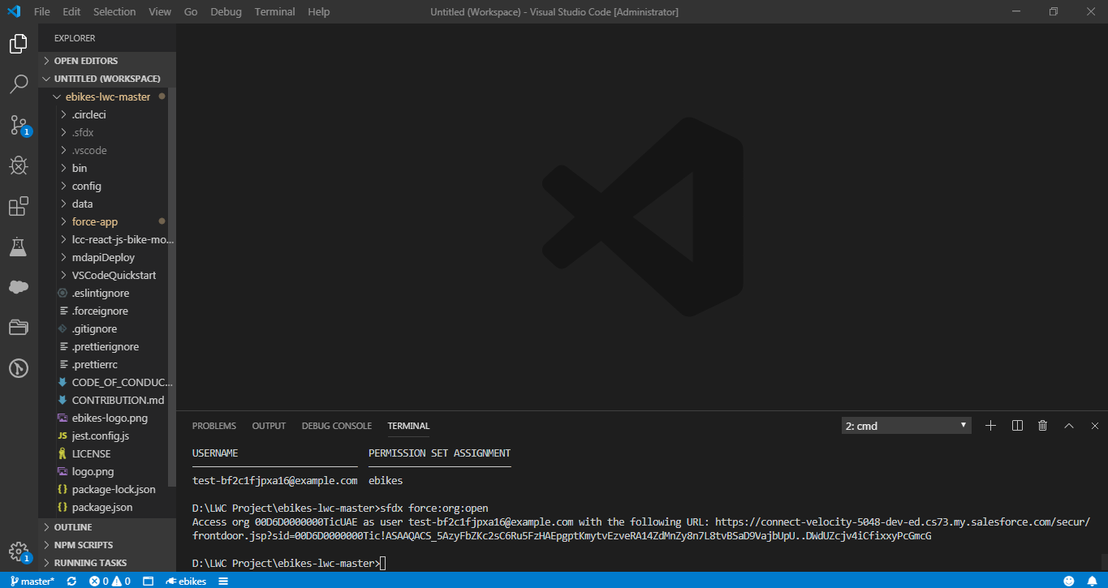

Once the scratch Org opens, go to App Launcher and open E-bikes app.

//Replace below image with image that shows E-bikes app instead of Car Dealer. I don’t have that. You can get this from Prathiba’s pc.

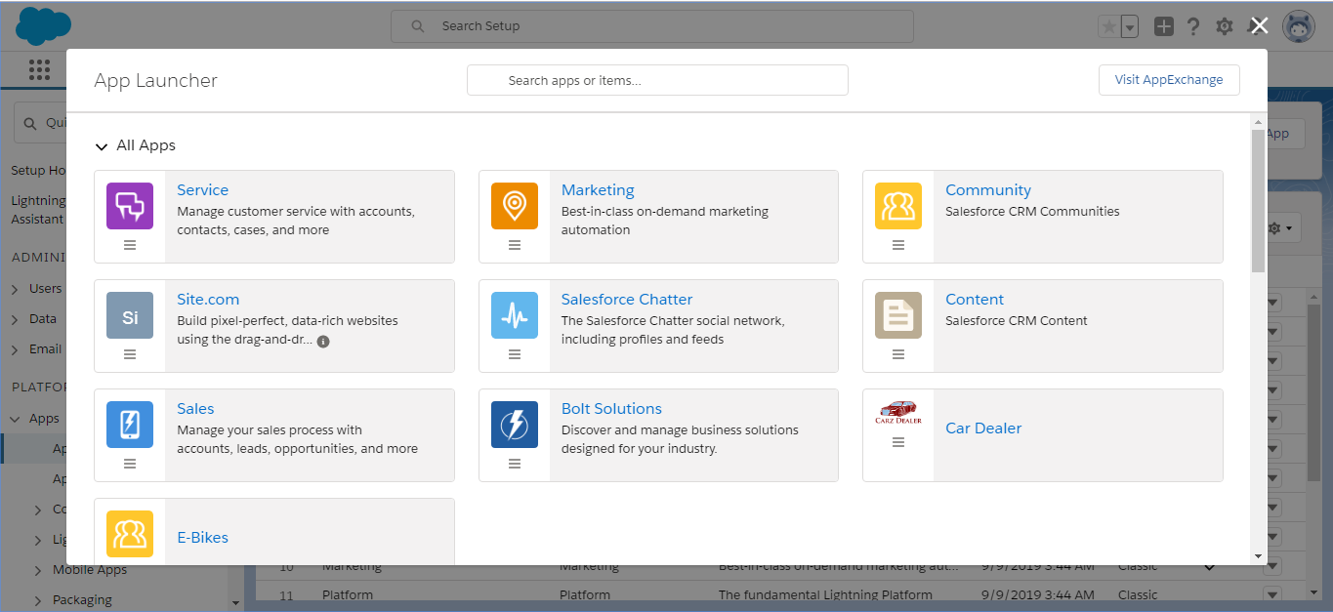

Explore the E-bikes app.

Home Page:

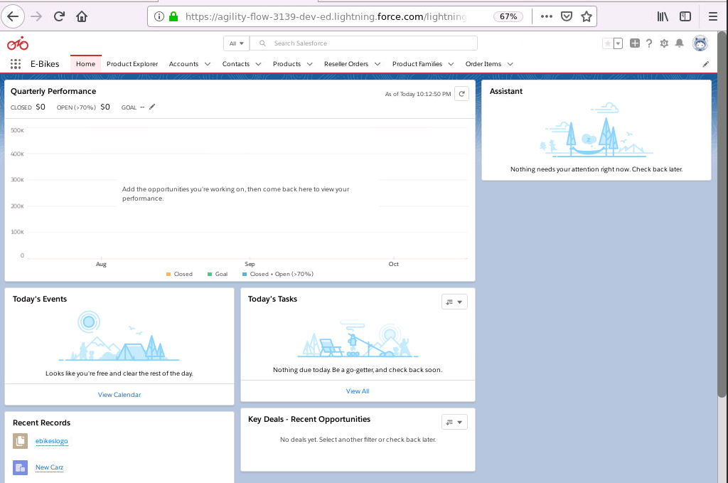

Product Explorer Page:

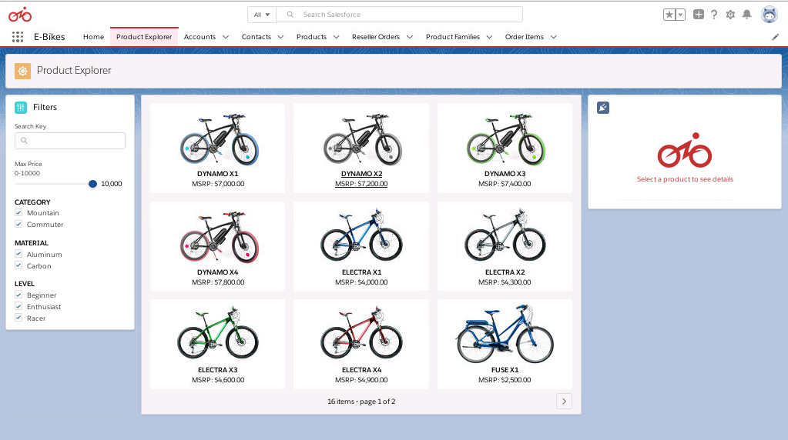

Product Explorer Page after clicking on a Product:

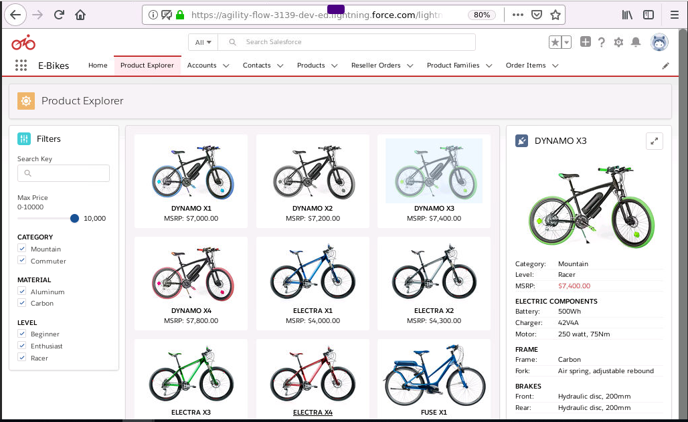

Account Record Page:

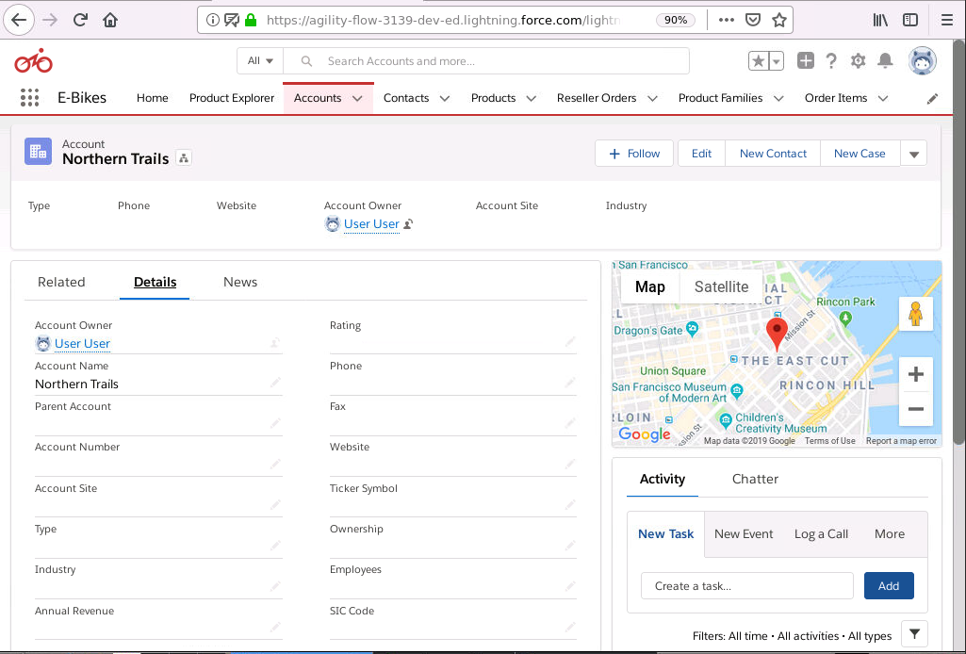

Product Record Page:

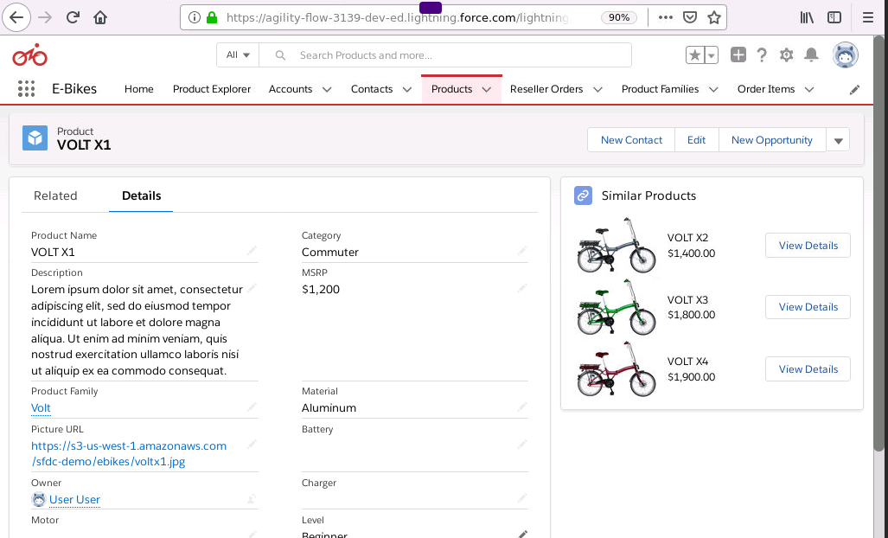

Reseller Order Record Page:

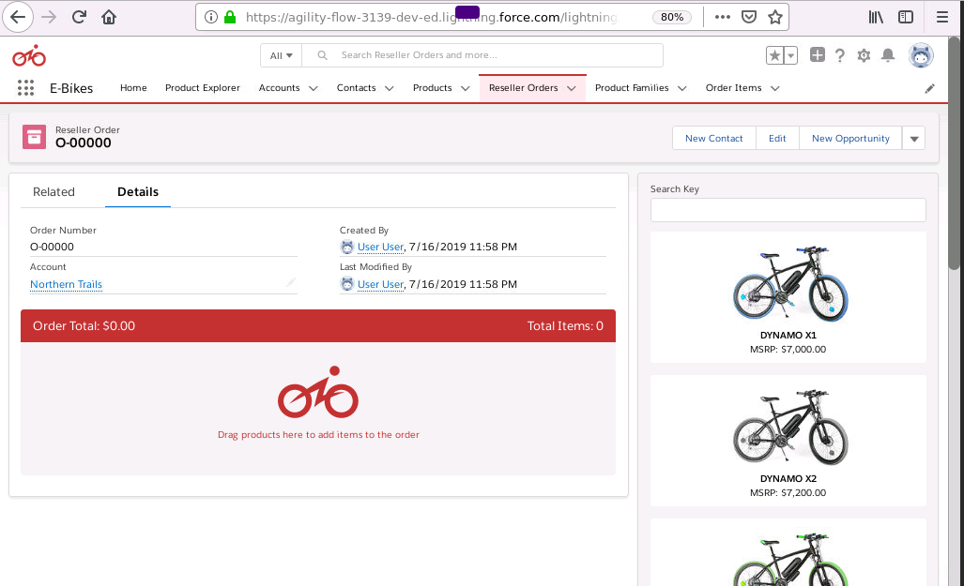

Reseller Order Record Page after dragging and dropping products:

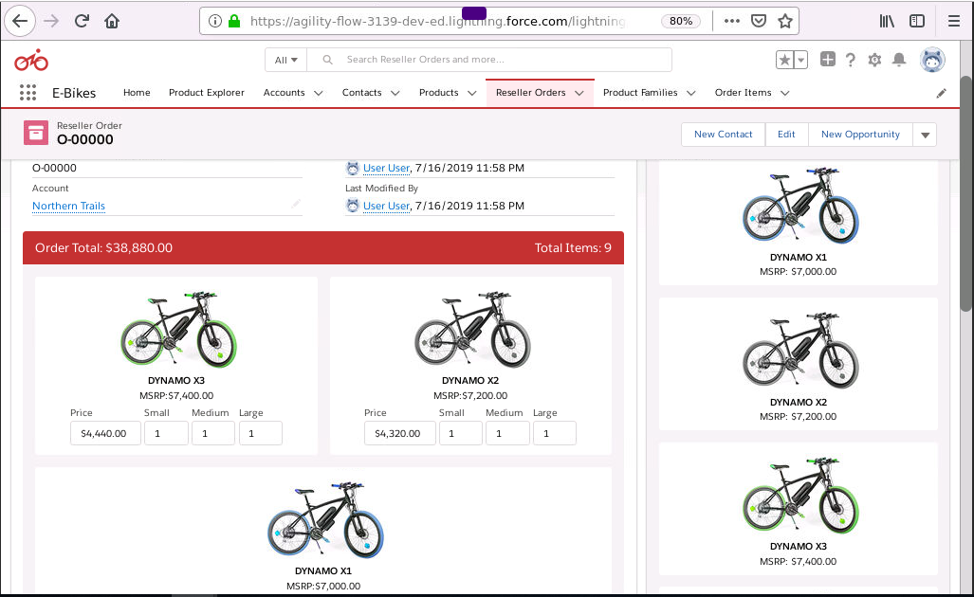

//Till here it is opening of E-bikes app as it is. Now Modification of E-bikes to Car Dealer comes into Picture

Step 1.3: Change the data model.

Step 1.3.1: Change the data model in your scratch org

//provide table

Step 1.3.2: Hide unwanted fields from Product layout.

Go to page layout of Product object and hide unwanted fields.

Step 1.4: Branding

Step 1.4.1: In Quick find search for App Manger. Edit the E-bikes app.

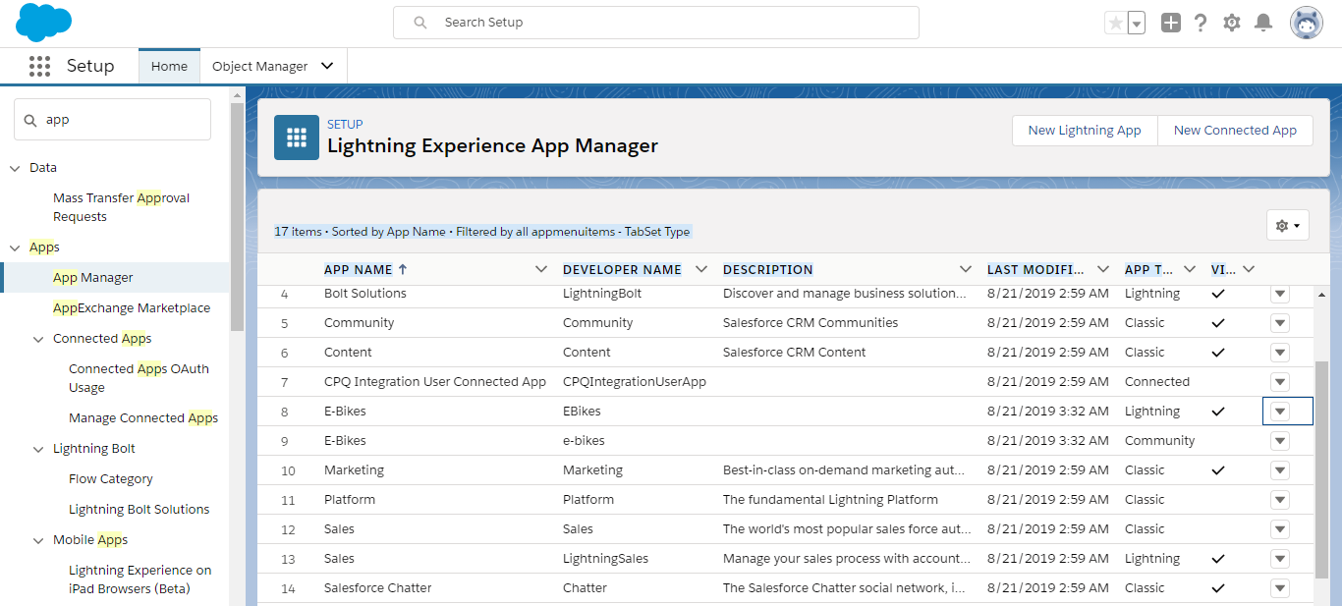

Step 1.4.2: Under App Details and Branding change the Image to the new logo and App name to Car Dealer.

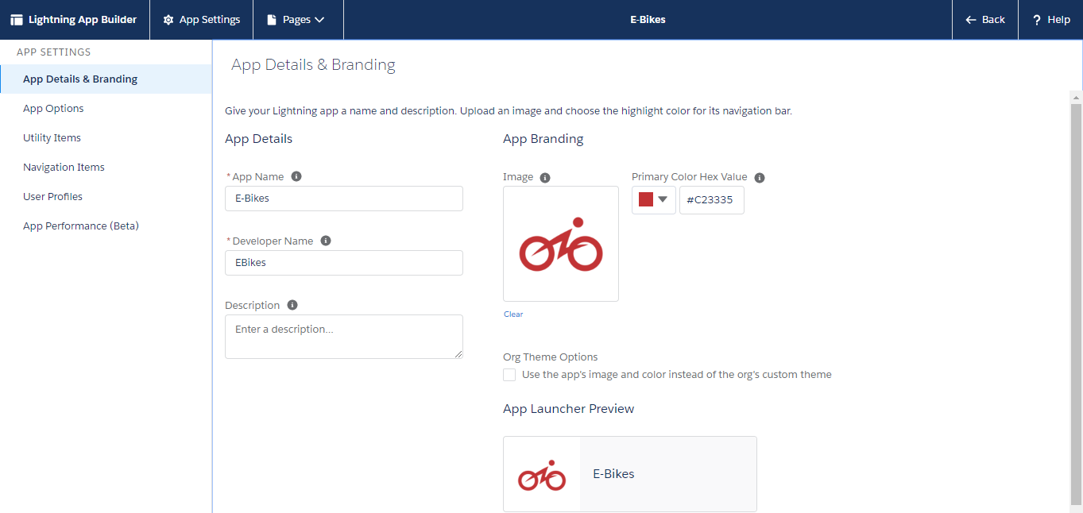

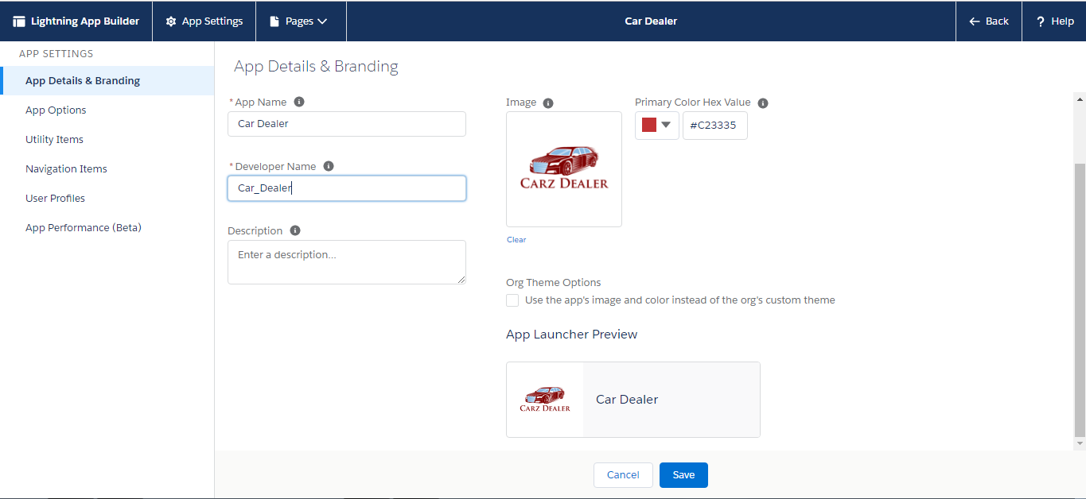

Step 1.4.3: Click Save.

Step 1.4.4: Pull the changes:

sfdxforce:source:pull

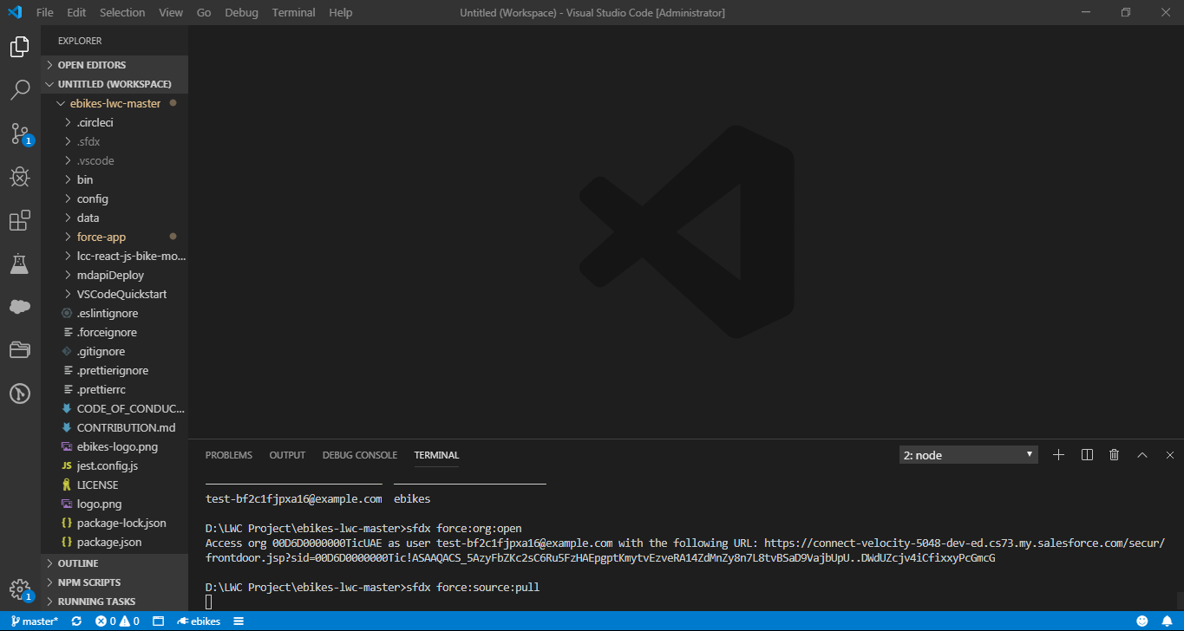

Step 1.4.5: Go to D:\LWC Project\ebikes-lwc-master\force-app\main\default\permissionsets\ebikes.permissionset-meta.xml and change Ebikes to Car_Dealer and save it.

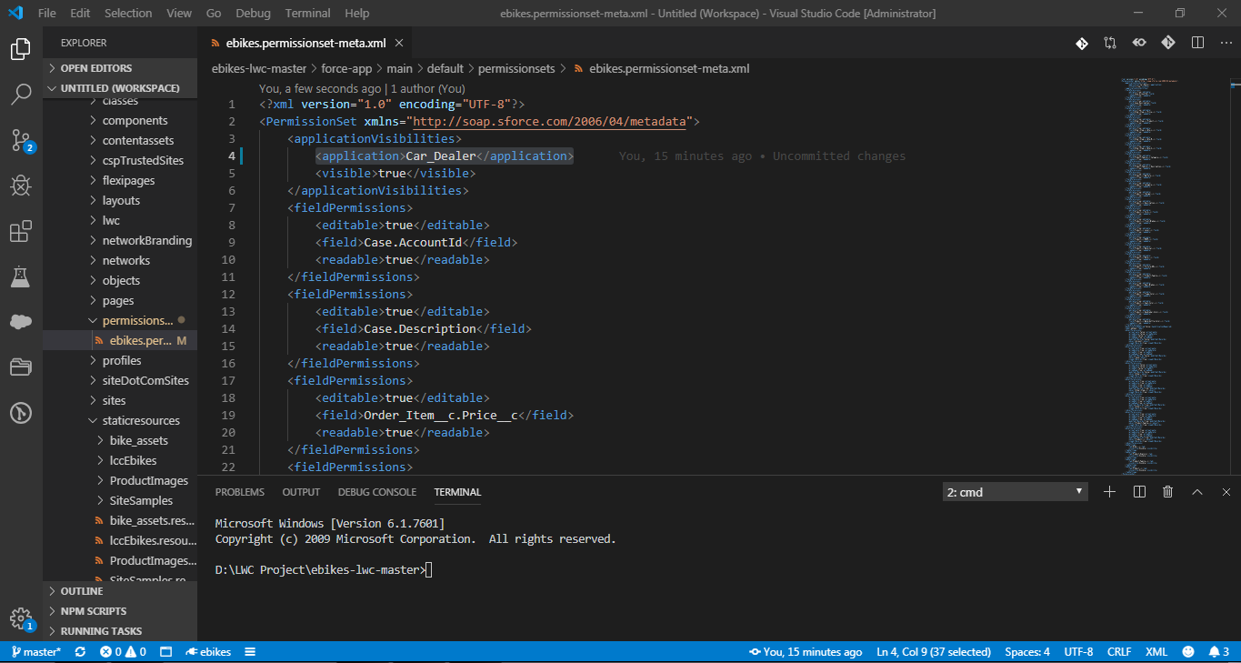

Step 1.4.6: Delete Scratch Org

sfdx force:org:delete

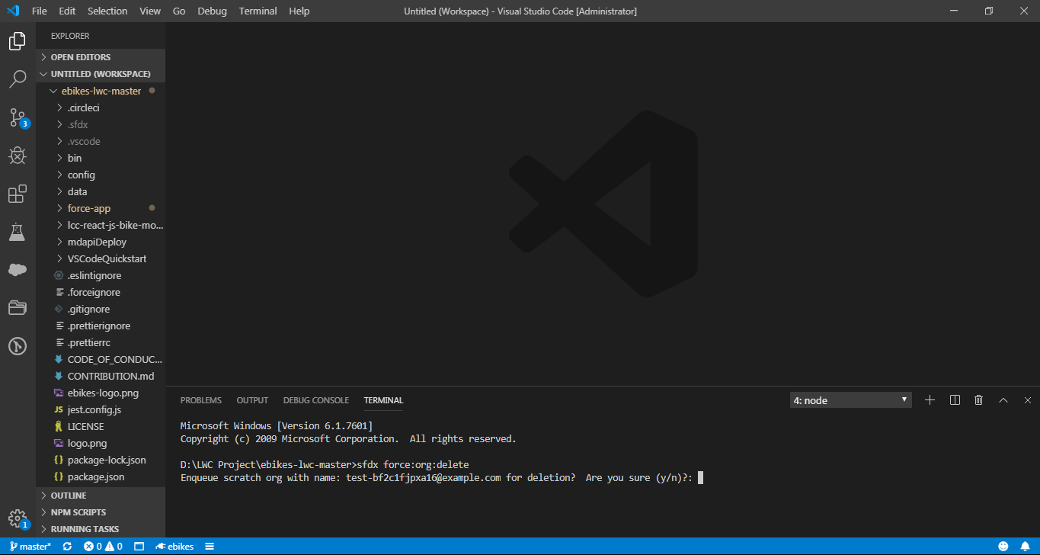

Press Y

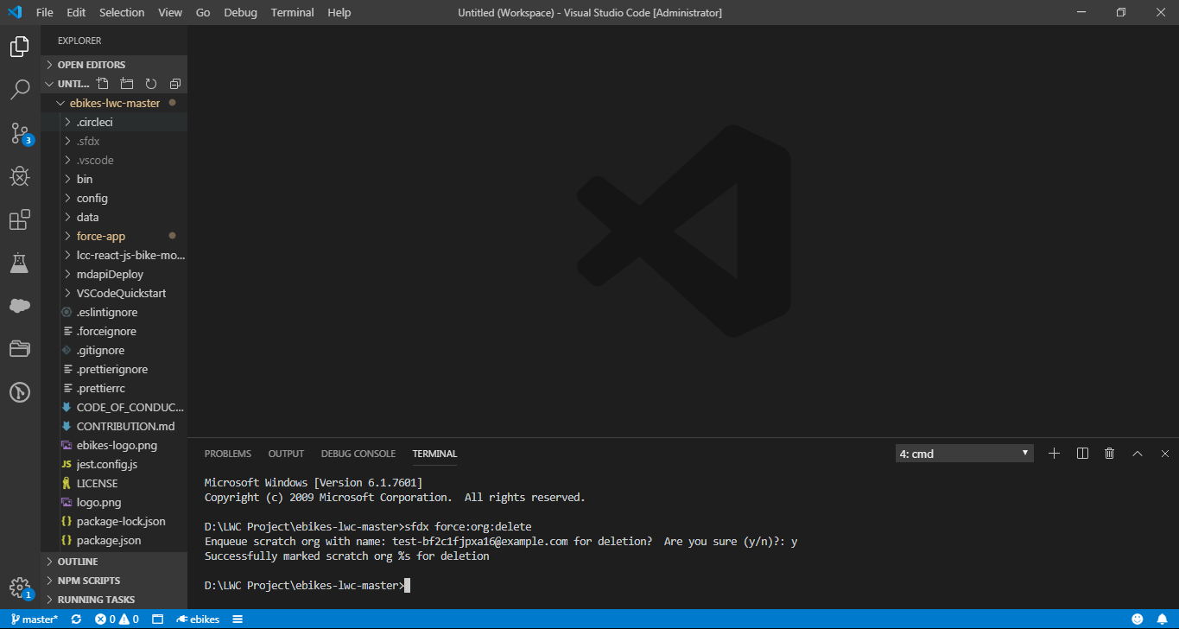

Step 1.5: Add static resource to your org

Step 1.5.1: Create a folder ProductImages in force-app>main>default>staticresources.

Step 1.5.2: Place images of cars inside this folder

//provide folder with the same car images from git

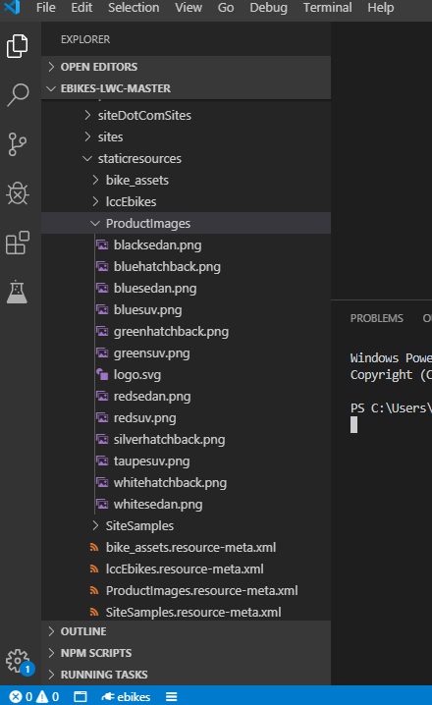

Step 1.5.3: Create a meta.xml file inside staticresources with the file name :

**ProductImages.resource-meta.xml**

Replace the existing code with the code given below:

<?xml version="1.0" encoding="UTF-8" ?>

<StaticResourcexmlns="http://soap.sforce.com/2006/04/metadata">

<cacheControl>Public</cacheControl>

<contentType>application/zip</contentType>

</StaticResource>

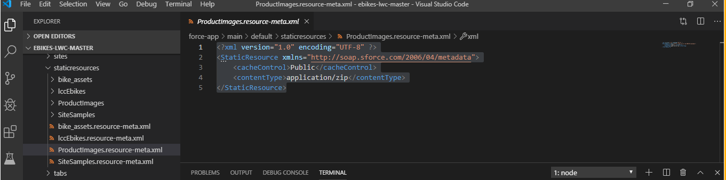

Step 1.6: Replace existing E-bikes images with new ones in the code

Step 1.6.1: Replace ebikes-logo.png and logo.png images with the corresponding new logo files.

Step 1.6.2: Replace ebikeslogo.png with new ebikeslogo.png file in ebikes-lwc-master\force-app\main\default\staticresources\IccEbikes

Step 1.6.3: Replace logo.svg file in the following location with the new logo.svg file

ebikes-lwc-master\force-app\main\default\staticresources\bike_assets

//Logos and car images are provided separately.

Step 1.7: Replace JSON files

Replace the code in following Json files in D:\LWC Project\ebikes-lwc-master\data with the codes provided

1)Accounts.json

2)Product__cs.json

3)Product_Family__cs.json

//Json files are provided separately

Step 1.8: Create New Scratch Org

Repeat the following steps:

1)Create new Scratch Org

2)Push the code

3)Load Sample Data

4)Open Scratch Org

Step 1.7: UI modifications //From here I think we can number as 2.1 etc

Step 1.7.1: Product filter:

Step 1.7.1.1: Open force-app>main>default>lwc>productFilter and replace the following codes.

1)productFilter.html

2)productFilter.js

//Codes to be provided separately as attached text files so that they can copy and paste.

Step 1.7.2: Product Tile:

Open force-app>main>default>lwc>productTile and replace the following codes.

1)productTile.css

Step 1.7.3: Product Card:

Open force-app>main>default>lwc>productCard and replace the following codes.

1)productCard.html

Step 1.7.4: Product List Item:

Open force-app>main>default>lwc>productListItem and replace the following codes.

1)productListItem.html

Step 1.7.5: Reseller Order:

To see changes in Reseller order we need to make changes in orderBuilder and orderItemTile.

Open force-app>main>default>lwc and replace the following codes.

1)orderBuilder.js

2)orderItemTile.html

Step 1.8: Push changes to the scratch org

//I think instead of making all the UI changes at once and pushing them, they can make changes, push and open for each component individually so that they can notice the changes of UI. Both of you discuss and decide on this

Step 1.4.1: Push the app to your scratch org:

sfdxforce:source:push

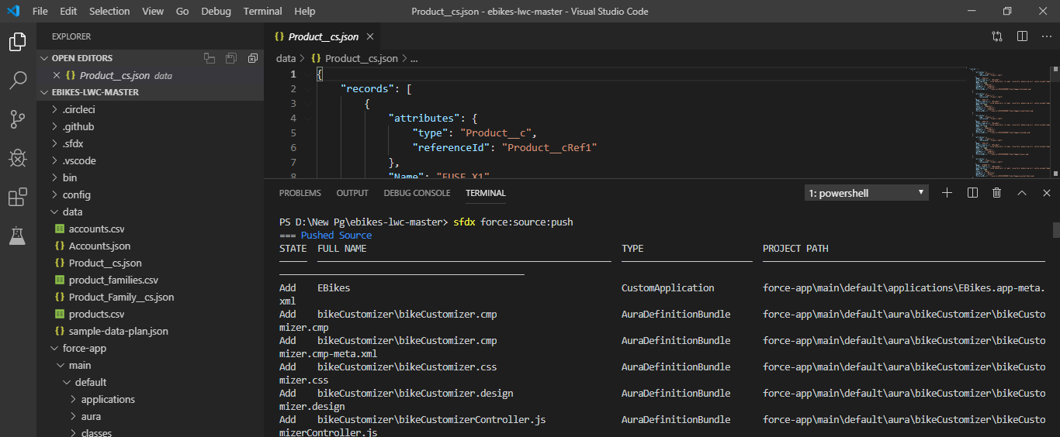

Step 1.4.3: Open the scratch org:

sfdxforce:org:open

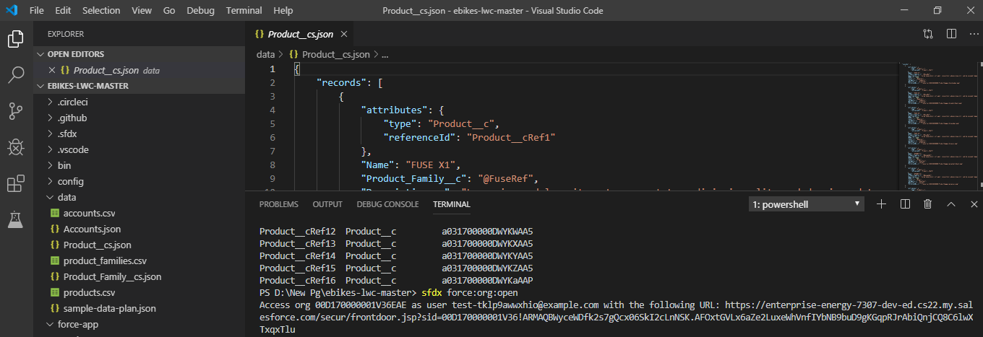

1.4: Explore the new App

Product Explorer:

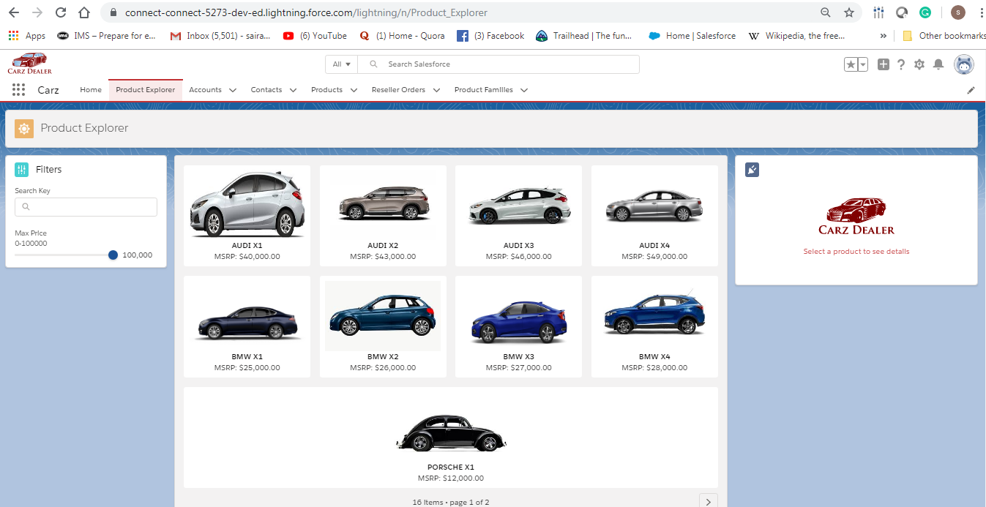

Product Explorer after selection of Product:

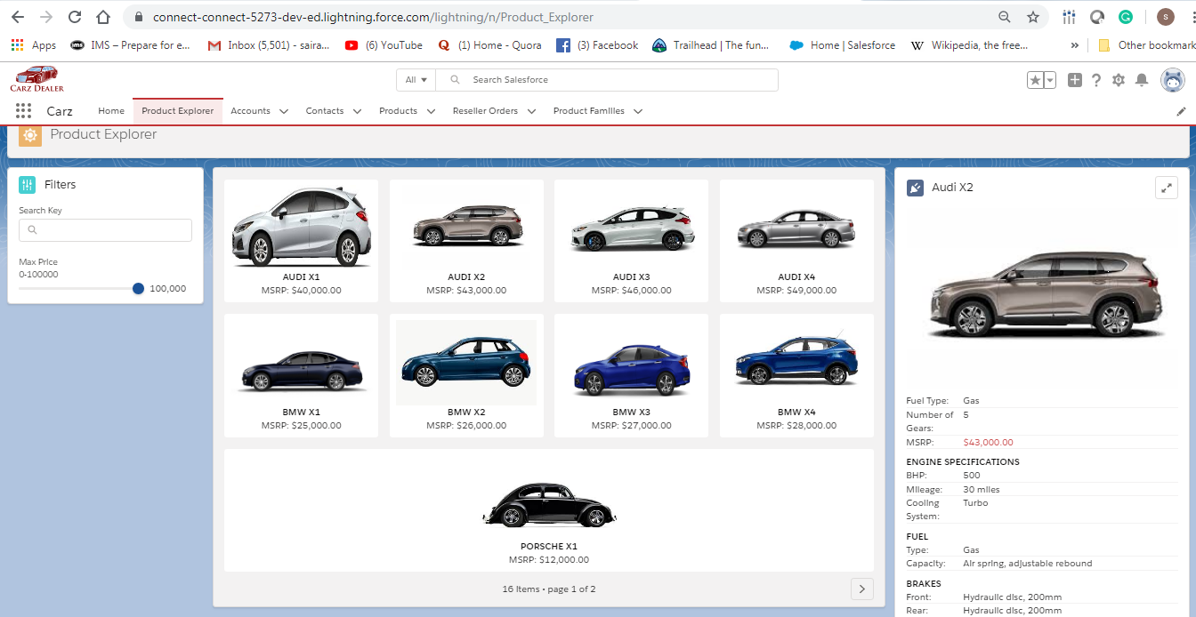

Reseller Order:

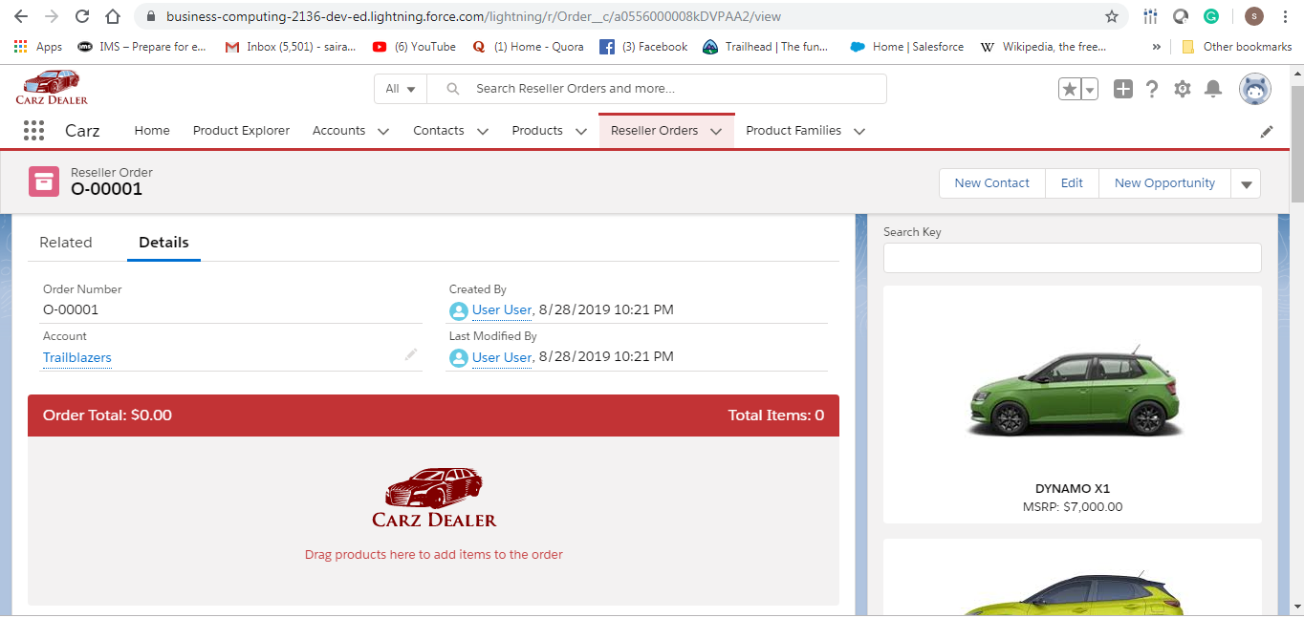

Reseller Order after dragging product into it:

